Jennifer Hood
Professor Michael Kimball
English 1010 – Visual Analysis Essay, 1st Draft
14 February 2013

It Doesn’t Hurt to Speak Up

We’ve all experienced a time in our lives when we’ve been afraid to do something. Whether it’s standing up to a bully, asking for clarification on an assignment, or taking the initiative on a project, we have all had a moment where courage has taken a back seat.

In the workplace, safety is paramount. While I won’t face the same dangers in my profession as someone who works with powerful machinery, employees need to be vigilant and take the initiative to make safety number one. Even the simplest misunderstanding can result in disaster.

WorkCover, the Australian government body responsible for managing their workers compensation fund, is responsible for these shocking ads. Similar to our Worker’s Compensation Fund here in Utah, WorkCover oversees work place occupational health and safety standards.

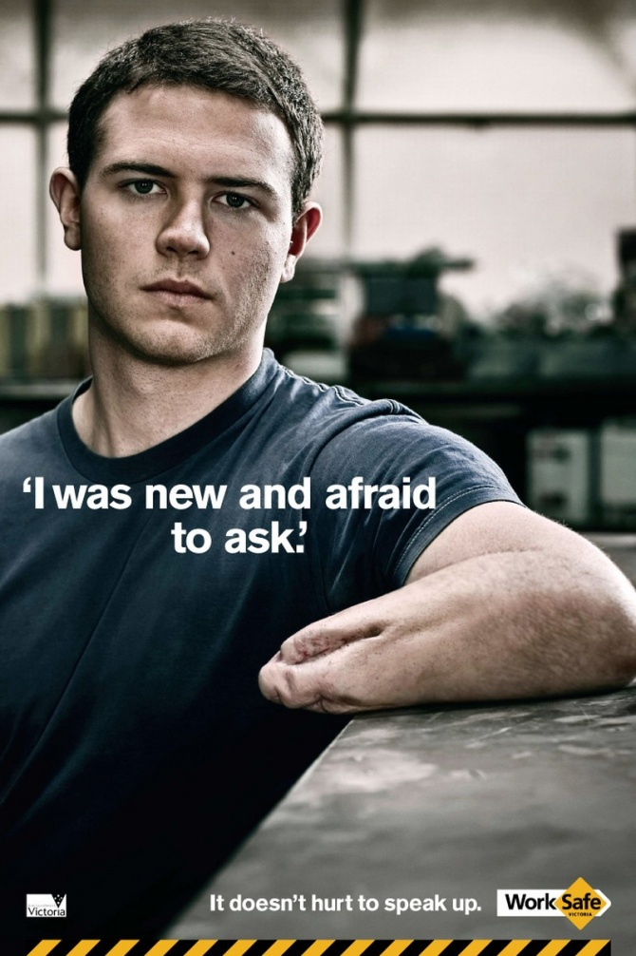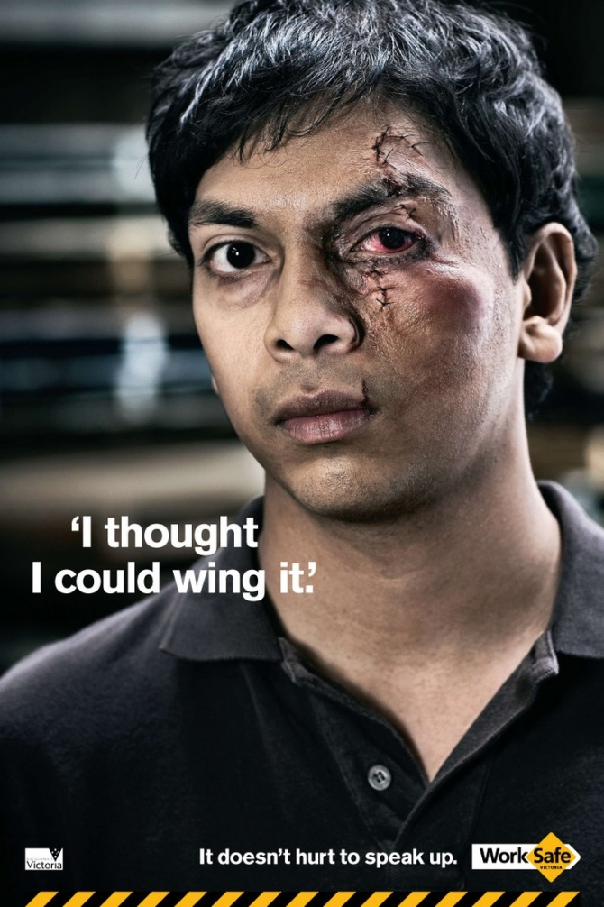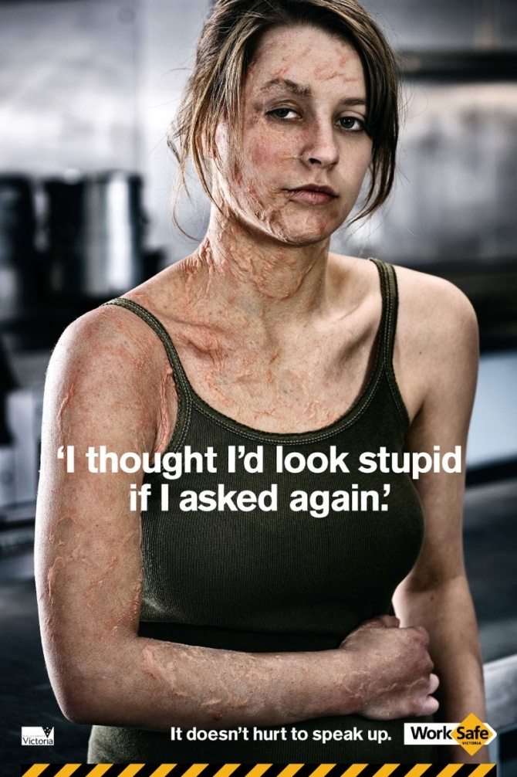

While their campaign addresses work place safety and stresses the idea that it doesn’t hurt to speak up, we can take the message and apply it into our daily lives. No matter the situation, we should not be afraid to speak up.

This campaign definitely focuses on our fears. For me, it really plays to my sense of not wanting to look like the people in the ads. To see their injuries and know that it can happen to anyone makes me take a closer look at how to prevent accidents around me.

I think there is a greater awareness of workplace safety now than in previous years. With the implementation of OSHA in 1971, employers are now required to provide safe working conditions for their employees. Fines and penalties certainly make an impact but regulation does not guard against someone who is ignorant which is why WorkCover’s ad campaign is so impactful.

For me, the statement in all three of these ads applies to reason. As I stated earlier, we’ve all had a moment where we’ve been afraid to ask. Each of us can identify with the reasoning that sometimes it’s scary or embarrassing to ask again or feel like we’re going to look stupid.

The credibility of the people in the ads comes from their very visible injuries. We’re not face to face with a minor cut or scrape but the loss of limb and deformities caused from a preventable accident. To simply mention that safety should be number one doesn’t convey the same message as a picture of a young man who is missing his hand.

Further playing on our emotions, the first image is more astonishing since the amputation is not a smooth “end”. Not only is the young man missing his hand but his arm looks like he has additional surgeries in his future.

While many advertisements may focus in on one particular group or culture, these ads can be understood all around the world. Obviously the language in which the text is written would change but the images convey a very powerful message no matter your job, religion, gender, race, or geographical location. Anyone can look at these ads and shudder at the thought of facing a debilitating injury.

In conclusion, workplace safety is up to all of use. Whether we work in a factory, an office building, or out of our home, we all need to pay attention to the dangers that we face. We need to stand up for our safety as well as the safety of others by not being afraid to ask. Which is worse? A momentary period of embarrassment or a lifetime of pain and suffering?

