Jennifer Hood
Professor Michael Kimball
English 1010
9 March 2013

Under the Rug
“Just a few more tweaks and I’ll be done”, Bill Jones thinks to himself as he works long into the night. A master electrician, Bill can often be found in the basement tinkering around with the many electronic gadgets he’s invented. His co-workers call him “Megavolt” because of his superhero ability to fix complex wiring problems. Even now with a splitting headache, Bill can’t wait to finish his latest project and presses on through the pain. Suddenly, he’s interrupted by a loud crash upstairs in the living room. He quickly leaves to investigate.
As Bill cracks open the basement door and peeks into the kitchen, everything is as it should be. He wonders if maybe he’s just hearing things. The house is as quiet as a mouse as Bill checks the back door to verify it is locked before heading into the living room. Soft light fills the room from a single lamp on a table as a very tired Bill looks around. Nothing appears to be out of place but as he turns to head back downstairs, Bill sees something moving under the carpet! “Aaaah!!” he screams as he jumps out of the way. The bulge moves toward him and then suddenly disappears. “What on earth?” he exclaims as he scratches his head trying to figure out what just happened. Bewildered, he starts to laugh as he realizes it’s his mind playing tricks on him and that he should probably get some sleep.
The next morning, eager to work on his project, Bill hurries to finish breakfast. He washes his bowl and sets it out to dry before heading down to the basement. Startled by a loud crash in the living room, he quickly turns around to see his lamp lying on the floor next to the couch. “Who’s there?” he yells out. No reply. He grabs a chef’s knife and cautiously heads into the living room to check it out.
The house is quiet and everything appears to be fine except the lamp on the floor. He stops to pick up the base and notices the finial is missing. Scanning the floor, he doesn’t see it anywhere. “That’s my favorite part!”, he thinks to himself as he bends down to check under the couch. Bill blinks his eyes and shakes his head in disbelief as he notices a strange bump in the carpet. He grabs the knife and stabs at the bulge only to see it vanish. “I’m not going crazy!” he exclaims as he stares into the shadows.
His headache from the night before has returned. Bill feels funny as he sits on the floor grasping his forehead. Figuring he needs a change of scenery, he decides to venture outside for some fresh air. Sure that his body is rebelling from working such long hours in the basement, Bill sets out to take a walk, It’s a beautiful summer day and the sky has never seemed so blue. The sweet smell of magnolia fills the air and reminds him of a simpler time. “Why do I lock myself inside all day when I can be experiencing this?” he wonders to himself.
Bill walks to the end of his street and hears children’s laughter. Following the melodious sound, he finds himself at a nearby park full of people enjoying their carefree day. Young mothers sit on a park bench keeping watchful eye over their little ones as they share the latest gossip. A young couple enjoys a picnic under a large oak tree while a group of young men play a rousing game of flag football. Bill stops to take it all in and remembers time’s past when he was a young boy. He loved going to the park with his dad to play catch. He reminisces about the Fourth of July celebration held every year where they enjoyed corn dogs, cotton candy, and the most spectacular fireworks he’d ever seen. Oh, what memories!
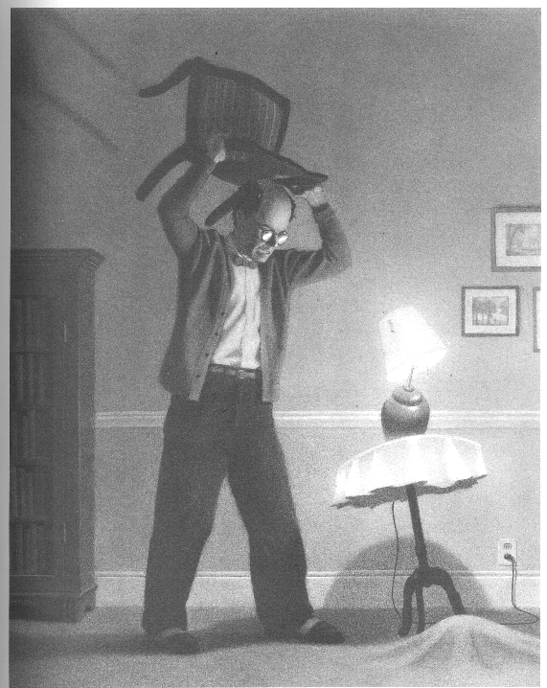
Almost two weeks have passed before Bill ventures down to the basement to pick up where he left off. Pieces of his project are scattered on his workbench and he feels like it’s time to get working again. As he straps on his leather tool belt, a loud crash comes from upstairs. The bulge in the carpet is back! Bill races up the stairs and runs into the living room just in time to see the bulge knock over the table and lamp. Without hesitation, Bill picks up a chair and smashes it to the ground. The bulge disappears and Bill is furious! “Stop fooling around, you coward!” he yells.
Two weeks passed and it happened again.
Frantically, Bill looks around the room trying to spot this mysterious intruder. He grabs a box cutter from his tool belt and cuts the carpet open. As he pulls back the layers, he hopes to find some evidence that he’s not losing his mind. To his dismay, the floor is intact. Confused over what is happening, his headache returns. Clutching his head, Bill curls up on the floor and quickly falls asleep.
When he awakes, Bill finds himself in the hospital recovering from a month-long coma. His nurse tells him a faulty circuit at work electrocuted him and he is lucky to be alive. Oh the irony! Bill is relieved he’ll recover but wonders what could have sparked such a weird dream. As he listens to the prognosis from his doctor, he’s surprised to hear that he actually died and was brought back to life. Was that the wonderful walk to the park? Had he really visited the other side? If that was heaven then the mysterious fight with the bulge in the carpet surely must have been hell.

